Stanford's AI is Self-Learning w/ Context Engineering: ACE
https://www.youtube.com/watch?v=elgYgPo_vY4
~ Prepared by Riya Kharade

1. Introduction
This documentation is based on a detailed research-focused video discussing Agentic Context Engineering (ACE) and recent breakthroughs in self-improving AI agents. The video analyzes new research contributions from Stanford University, UC Berkeley, Meta Superintelligence, and Ohio State University, which collectively challenge the traditional dominance of supervised fine-tuning and reinforcement learning in AI system improvement.
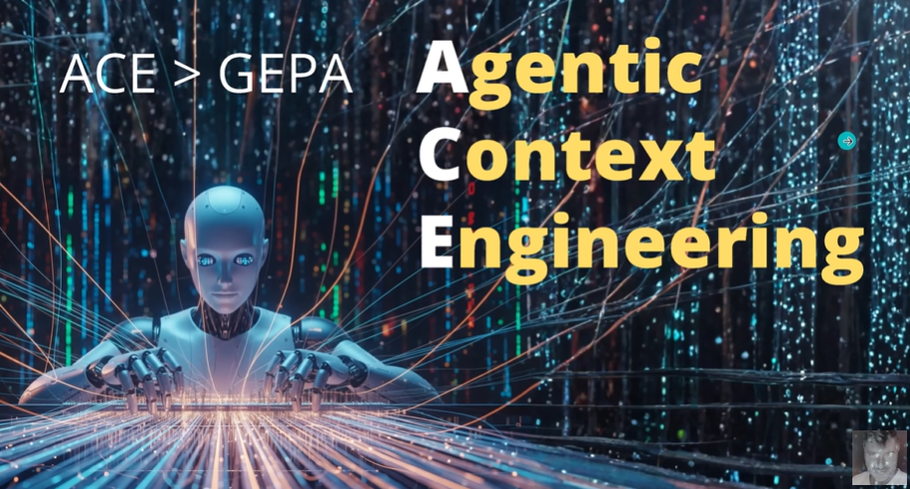
The video explains why classical post-training techniques such as supervised fine-tuning suffer from data scarcity and limited generalization, while reinforcement learning often becomes impractical in reward-sparse or unverifiable environments. As an alternative, the video introduces a reward-free, interaction-driven learning paradigm, where agents improve by interacting directly with real-world environments, generating their own learning signals, and refining behavior through self-reflection and structured memory updates.
A central focus of the video is Agentic Context Engineering (ACE)—a method that allows AI agents to evolve their internal context or memory incrementally, without catastrophic forgetting or excessive summarization. The video also demonstrates how ACE can be combined with early experience learning to create a self-reinforcing learning loop, enabling agents to continuously improve performance across complex, real-world tasks such as flight booking.

2. Limitations of Traditional Learning Approaches
2.1 Supervised Fine-Tuning
Supervised fine-tuning relies on:
- Expert-labeled data
- Predefined demonstrations
- Static datasets
Limitations:
- Limited exposure to failures and edge cases
- Poor out-of-distribution generalization
- High cost of collecting expert data

2.2 Reinforcement Learning
Reinforcement learning depends on:
- Explicit reward functions
- Verifiable success signals
Limitations:
- Infeasible in reward-sparse environments
- Hard to design correct reward functions
- High computational overhead
These limitations motivate the search for low-overhead alternatives that do not require large labeled datasets or explicit reward structures.

3. Shift Toward Interaction-Based Learning
The video highlights a key insight:
Models can learn effectively by interacting with real or simulated environments and generating their own learning data.
Instead of isolating the AI and asking it to reflect internally, learning is driven by:
- Real-world actions
- Observable outcomes
- Execution feedback
This approach is especially effective in:
- Rapidly changing environments
- Systems without ground-truth rewards
- Long-horizon decision-making tasks

4. Early Experience Learning (Implicit World Modeling)
The first research component discussed is Early Experience (EE) learning, which introduces two core ideas:

4.1 Implicit World Modeling (IWM)
- The agent learns environment dynamics implicitly
- Training data consists of (state, action, next state) triplets
- No explicit reward function is required
The agent predicts outcomes of actions and learns cause–effect relationships through repeated interaction.

4.2 Self-Reflection
- The agent critiques its own failed or suboptimal trajectories
- Instead of binary rewards, it generates natural language lessons
- These lessons are generalizable and reusable across domains
Key Benefit:
Self-reflection produces transferable rules, not just success/failure signals.

5. Example: Flight Booking with Early Experience
An AI agent is initialized using a small set of expert demonstrations (e.g., 10 flight booking trajectories).
Initial performance:
- ~60% success on familiar tasks
- ~40% on out-of-distribution tasks
Through interaction:
- The agent explores multiple partial trajectories
- Learns which actions lead to errors (e.g., selecting sold-out flights)
- Generates reflections such as:
“Check availability before selecting a flight.”
This improves:
- In-domain success to ~70%
- Out-of-domain generalization significantly

6. Problem: Context Collapse in Long-Running Agents
A major challenge in self-improving agents is context collapse.
What is Context Collapse?
- When LLMs repeatedly rewrite long prompts or memories
- The model suddenly over-summarizes
- Detailed domain knowledge is permanently lost
Effects:
- Sharp drop in performance
- Irreversible forgetting
- Reduced accuracy over time
This problem makes naive memory rewriting unsuitable for long-horizon agents.

7. Agentic Context Engineering (ACE)
7.1 Core Idea
ACE treats agent memory as an evolving playbook, not a single monolithic prompt.
Instead of rewriting the entire context:
- Knowledge is added incrementally
- Updates are precise and structured
- No large-scale summarization occurs
7.2 Modular Roles in ACE
ACE uses three functional roles:
- Generator
  - Executes actions using current context
  - Produces trajectories
- Reflector
  - Analyzes failures or inefficiencies
  - Extracts concise, general lessons
- Creator
  - Applies delta updates
  - Appends new rules to the playbook without rewriting existing content
This design eliminates context collapse and preserves domain-specific knowledge.
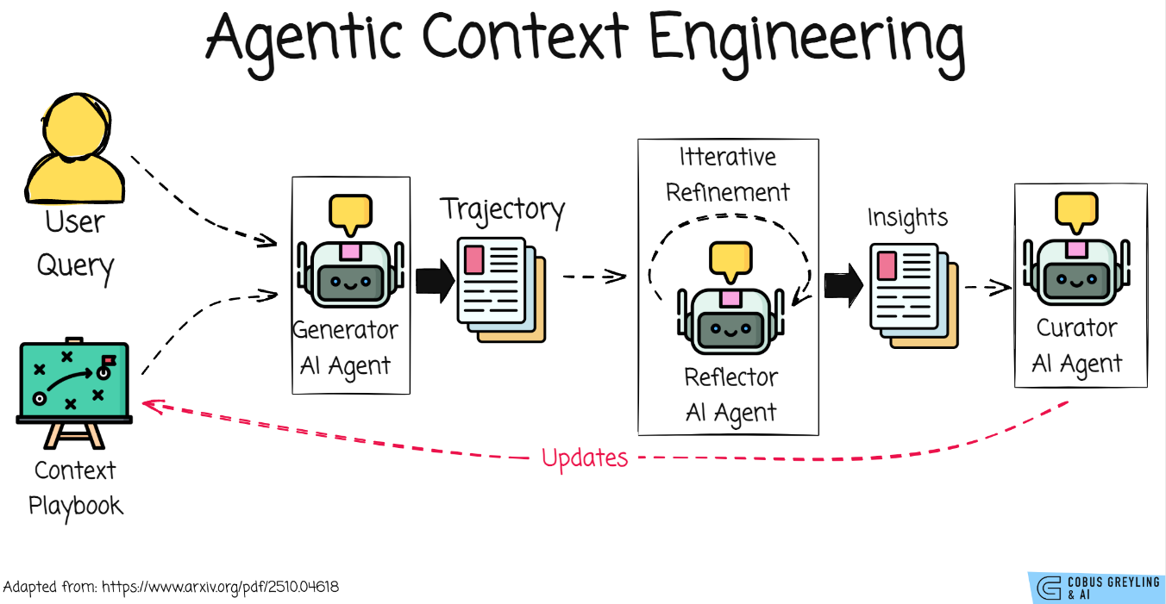

8. Avoiding Brevity Bias
Brevity Bias
LLMs tend to prefer:
- Shorter prompts
- Generic instructions
- Loss of domain-specific details
ACE explicitly prevents brevity bias by:
- Storing detailed rules permanently
- Appending knowledge instead of compressing it
- Maintaining structured, explicit strategies

9. Combining Early Experience and ACE
The video demonstrates a two-loop architecture:
Inner Loop (Early Experience)
- Agent interacts with environment
- Learns from execution feedback
- Generates raw experiential data
Outer Loop (ACE)
- Reflects on experiences
- Extracts strategic insights
- Updates long-term playbook
This creates a virtuous cycle of self-improvement:
- Better exploration → better insights
- Better insights → smarter future actions

10. Performance Improvements Reported
Early Experience Results
- ~10% improvement over supervised fine-tuning
- Requires ~50% less expert data
- Improves reinforcement learning warm-start performance
ACE Results
- ~8–12% performance gains without ground-truth labels
- Up to 86% lower latency
- Up to 75% fewer rollouts
- Significant cost reduction
- No model weight updates required
These results demonstrate that context engineering can rival or outperform fine-tuning at a fraction of the cost.

11. Advantages of Agentic Context Engineering
- Eliminates catastrophic forgetting
- No reward function required
- No model fine-tuning needed
- Works with black-box LLMs
- Scales to complex, real-world tasks
- Supports long-horizon reasoning

12. Applications
- Flight and travel booking agents
- Financial operations
- Enterprise automation
- Multi-step workflow agents
- Long-running autonomous systems

13. Conclusion
The video presents Agentic Context Engineering as a powerful alternative to traditional fine-tuning and reinforcement learning. By combining environment interaction, self-reflection, and incremental memory updates, AI agents can continuously improve without catastrophic forgetting or heavy computational costs.
When paired with Early Experience learning, ACE enables the creation of self-improving, reward-free, long-horizon agents capable of operating reliably in complex and uncertain environments. This represents a significant step forward in the design of scalable, autonomous AI systems.

